**FACIAL RECOGNITION**

**ECB4243 DESIGN PROJECT-2**

***Submitted by,***

**Meenakshi.S.S (191210102)**

**Jenish Savaliya (19121014)**

**Rakesh.K (19121016)**

***As a part of the second year***

***curriculum of***

**BACHELOR OF TECHNOLOGY**

**IN**

**ELECTRONICS AND COMMUNICATION ENGINEERING**



**SCHOOL OF ELECTRICAL SCIENCES**

**APRIL 2021**

**ABSTRACT:**

The face is one of the easiest ways to distinguish the individual identity of each other. Face recognition is the task of identifying an already detected object as a known or unknown face Face recognition is a personal identification system that uses personal characteristics of a person to identify the person's identity. Human face recognition procedure basically consists of two phases, namely face detection, where this process takes place very rapidly in humans, except under conditions where the object is located at a short distance away, the next is the introduction, which recognize a face as individuals. Stage is then replicated and developed as a model for facial image recognition (face recognition) is one of the much-studied biometrics technology and developed by experts. The area of this project facial recognition is Image Processing.

Extension: There are vast number of applications from this face detection project, this project can be extended that the various parts in the face can be detect which are in various directions and shapes

**INDEX**

**TABLE OF CONTENTS**

**ABSTRACT**

|  |  |  |
| --- | --- | --- |
| **S.NO** | **TOPICS** | **PAGE NO** |
| **1** | **INTRODUCTION** | **4** |
| **2** | **BLOCK DIAGRAM** | **5** |
| **3** | **COMPONENTS REQUIRED** | **6-7** |
| **4** | **FRAMEWORKS USED** | **8** |
| **5** | **COMPONENT DESCRIPTION** | **9-12** |
| **6** | **NEURAL NETWORK ARCHITECTURE** | **13** |
| **7** | **PROGRAM CODE** | **14-16** |
| **8** | **MERITS** | **17-18** |
| **9** | **DEMERITS** | **19** |
| **10** | **APPLICATIONS** | **20-21** |
| **11** | **CONCLUSION AND FUTURE SCOPE** | **22** |
| **12** | **REFERENCES** | **23** |

**1.INTRODUCTION**

Face recognition is the task of identifying an already detected object as a known or unknown face. Face recognition system is a complex image-processing problem in real world lications with

complex effects of illumination, occlusion, and imaging condition on the live images. It is a

combination of face detection and recognition techniques in image analyzes. Detection

application is used to find position of the faces in a given image. Recognition algorithm is used

to classify given images with known structured properties, which are used commonly in most of

the computer vision applications. Recognition applications use standard images, and detection

algorithms detect the faces and extract face images which include eyes, eyebrows, nose, and

mouth. That makes the algorithm more complicated than single detection or recognition

algorithm. The first step for face recognition system is to acquire an image from a camera.

Second step is face detection from the acquired image. As a third step, face recognition that

takes the face images from output of detection part. Final step is person identity as a result of

recognition part

Face recognition system is a complex image-processing problem in real world applications with complex effects of illumination, occlusion, and imaging condition on the live images. It is a combination of face detection and recognition techniques in image analyses. Detection application is used to find position of the faces in a given image. Recognition algorithm is used to classify given images with known structured properties, which are used commonly in most of the computer vision applications. Recognition applications use standard images, and detection algorithms detect the faces and extract face images which include eyes, eyebrows, nose, and mouth. That makes the algorithm more complicated than single detection or recognition algorithm. The first step for face recognition system is to acquire an image from a camera. Second step is face detection from the acquired image. As a third step, face recognition that takes the face images from output of detection part. Final step is person identity as a result of recognition part.We have created a system which would be able to accept a set of user images which can then be compared to the incoming images taken from Raspberry Pi camera to detect faces and unlock doors.

**2.BLOCK DIAGRAM**

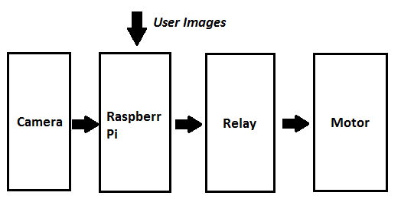

**Fig 2.1**

**3.COMPONENTS REQUIRED:**

1. Rasberry Pi 4

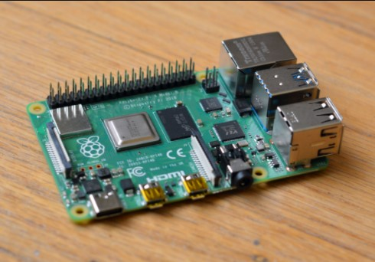

**Fig 3.1.1**

1. 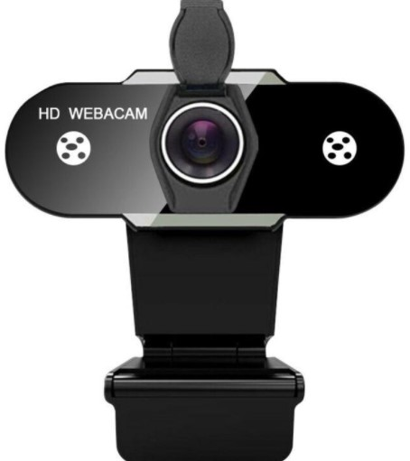Web Camera 720p

**Fig 3.2.1**

1. 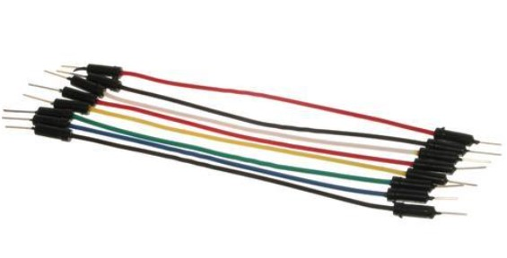Connecting cables

**Fig 3.3.1**

1. 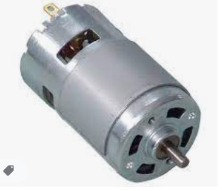DC Motor

**Fig 3.4.1**

1. 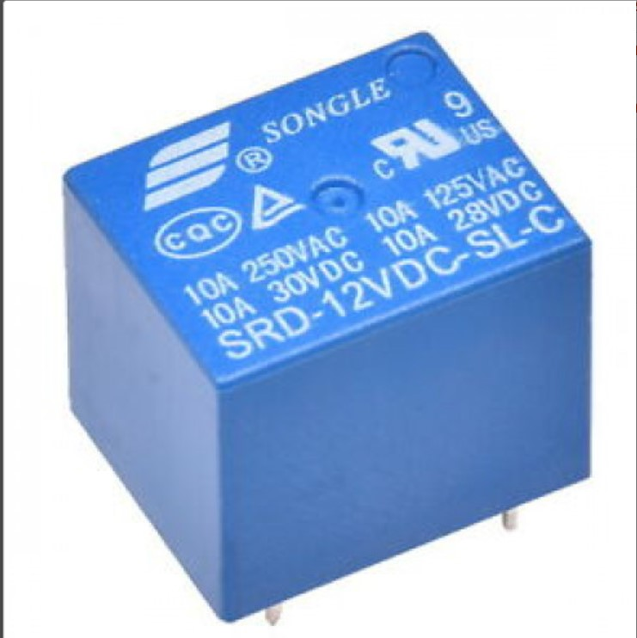Relay 12V

**fig 3.5.1**

1. Power source

4.**FRAMEWORKS USED:**

**1.**Python:

**Fig 4.1.1**

**2.** OpenCV

**Fig 4.2.1**

**3.** Caffe

**Fig 4.3.1 **

**5.COMPONENTS DESCRIPTION**

1. Rasberry Pi 4:

Single board computer. The Raspberry Pi is a very cheap computer that runs Linux, but it also provides a set of GPIO pins that allow you to control electronic components for physical computing and explore the Internet of Things

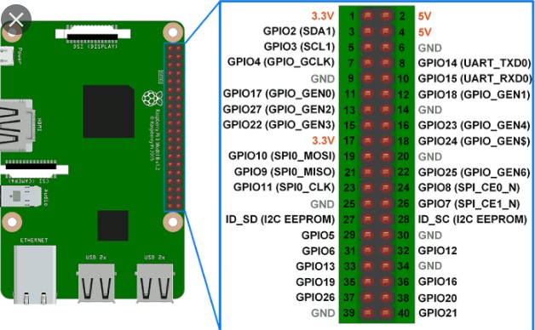

**Fig 5.1.1**

Few of the special features of Rasberry Pi 4 over the other series of the minicomputer are:-

* Silent, energy-efficient

The fanless, energy-efficient Raspberry Pi runs silently and uses far less power than other computers.

* Fast networking

Raspberry Pi 4 comes with Gigabit Ethernet, along with onboard wireless networking and Bluetooth.

* USB 3

Your new Raspberry Pi 4 has upgraded USB capacity: along with two USB 2 ports you'll find two USB 3 ports, which can transfer data up to ten times faster

**2.**Web Camera 720p

This is a video camera that feeds or streams an image or video in real time. We have used a 720p camera meaning the incoming image feed is of 720x720x3 dimensions

**3.**DC Motor

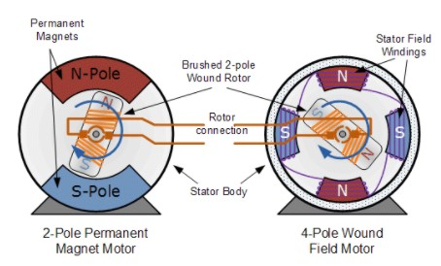 This is a device that converts electrical energy to mechanical energy. It is an actuator i.e. causes an action to take place. Electrical DC Motors are continuous actuators that convert electrical energy into mechanical energy. The DC motor achieves this by producing a continuous angular rotation that can be used to rotate pumps, fans, compressors, wheels, etc.

**Fig 5.3.1**

Electric motors turn electricity into motion by exploiting electromagnetic inductionThe motor features a permanent horseshoe magnet (called the stator because it’s fixed in place) and an turning coil of wire called an armature (or rotor, because it rotates). The armature, carrying current provided by the battery, is an electromagnet, because a [current-carrying wire](https://nationalmaglab.org/education/magnet-academy/watch-play/interactive/magnetic-field-around-a-wire-i) generates a magnetic field; invisible magnetic field lines are circulating all around the wire of the armature.

The key to producing motion is positioning the electromagnet within the magnetic field of the permanent magnet (its field runs from its north to south poles). The armature experiences a force described by the [left hand rule](https://nationalmaglab.org/education/magnet-academy/watch-play/interactive/right-and-left-hand-rules). This interplay of magnetic fields and moving charged particles (the electrons in the current) results in the torque

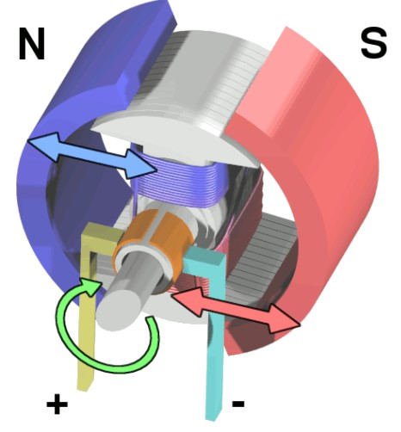that makes the armature spin.

**Fig 5.3.2**

4.Relay

It is a electromagnetic device, which acts as a switch therefore enabling the user to control the device by switching the current on and off. Relays are switches controlled by electrical power, like another switch, computer or control module. The purpose of an automotive relay is to automate this power to switch electrical circuits on and off at particular times. However, the real benefit behind a relay is more than just automation; they also provide the ability to switch multiple circuits, including different voltage types, within the same relay at the same time.

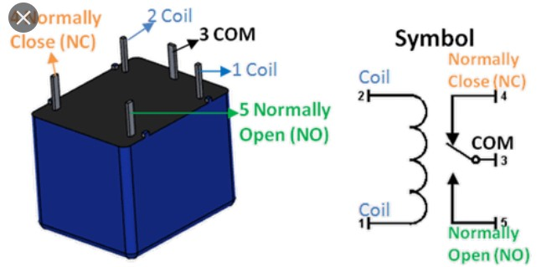[12V DC relay switches](http://www.delcity.net/store/Relays-&-Power-Distribution/) are the best solution for full voltage applications, as they allow a low current flow circuit to control a high current flow circuit, like a vehicle’s horn, headlights, auxiliary lamps, fan motors, blower motors and countless pieces of equipment existing on vehicles today.

**Fig 5.4.1**

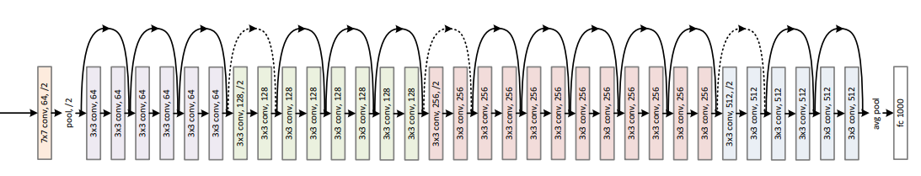**6.NEURAL NETWORK ARCHITECTURE**

**Fig 6.1.1**

* Based on Residual Neural Network 34
* >30 million parameters
* Pre trained model , trained with 3 million images

**7.PROGRAM CODE**

import RPi.GPIO as GPIO

from imutils.video import VideoStream

from imutils.video import FPS

from time import sleep

import face recognition

import imutils

import pickle

import time

import cv2

currentname = "unknown"

encodingsP = "encodings.pickle"

cascade = "haarcascade_frontalface_default.xml"

print("[INFO] loading encodings + face detector...")

data = pickle.loads(open(encodingsP, "rb").read())

detector = cv2.CascadeClassifier(cascade)

print("[INFO] starting video stream...")

vs = VideoStream(src=0).start()

time.sleep(2.0)

fps = FPS().start()

while True:

frame = vs.read()

frame = imutils.resize(frame, width=500)

gray = cv2.cvtColor(frame, cv2.COLOR_BGR2GRAY)

rgb = cv2.cvtColor(frame, cv2.COLOR_BGR2RGB)

rects = detector.detectMultiScale(gray, scaleFactor=1.1,

minNeighbors=5, minSize=(30, 30),

flags=cv2.CASCADE_SCALE_IMAGE)

boxes = [(y, x + w, y + h, x) for (x, y, w, h) in rects]

encodings = face_recognition.face_encodings(rgb, boxes)

names = []

for encoding in encodings:

matches = face_recognition.compare_faces(data["encodings"],

encoding)

name = "Unknown"

if True in matches:

matchedIdxs = [i for (i, b) in enumerate(matches) if b]

counts = {}

for i in matchedIdxs:

name = data["names"][i]

counts[name] = counts.get(name, 0) + 1

GPIO.setmode(GPIO.BCM)

GPIO.setup(17, GPIO.OUT)

GPIO.output(17, GPIO.LOW)

time.sleep(3)

GPIO.output(17, GPIO.HIGH)

GPIO.cleanup()

name = max(counts, key=counts.get)

if currentname != name:

currentname = name

print(currentname)

names.append(name)

for ((top, right, bottom, left), name) in zip(boxes, names):

cv2.rectangle(frame, (left, top), (right, bottom),

(0, 255, 225), 2)

y = top - 15 if top - 15 > 15 else top + 15

cv2.putText(frame, name, (left, y), cv2.FONT_HERSHEY_SIMPLEX,

.8, (0, 255, 255), 2)

cv2.imshow("Facial Recognition is Running", frame)

key = cv2.waitKey(1) & 0xFF

if key == ord("q"):

break

fps.update()

fps.stop()

print("[INFO] elasped time: {:.2f}".format(fps.elapsed()))

print("[INFO] approx. FPS: {:.2f}".format(fps.fps()))

cv2.destroyAllWindows()

vs.stop()

**8.MERITS**

Facial recognition has many benefits in society, including increasing safety and [security](https://www.itpro.com/security), preventing crimes, and reducing human interaction. It can even help support medical efforts, in some cases.

**1. Helps find missing people**

Law enforcement agencies use facial recognition to find missing people, and they've also used it to find missing children.

When combined with aging software that shows how the child would look several years later, facial recognition can even help find someone who’s been missing for years.

1. **Protects businesses against theft**

Business owners use facial recognition software and security cameras to identify known or suspected thieves as they enter their stores. This pre-emptive security measure can help prevent shoplifting.

Since people are less likely to commit a crime when they know they are being watched, the technology also serves as a deterrent.

1. **Strengthens security measures**

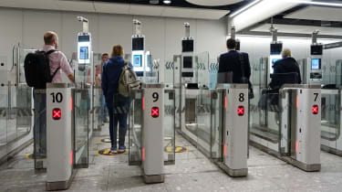 **Fig 8.3.1**

Facial recognition also helps improve safety and [security](https://www.itpro.com/security) too.

Facial recognition has been a regular part of Airport security screening for many years, helping identify criminals and potential threats to airlines and passengers.

Banks and other institutions also use facial recognition to prevent fraud, as the technology can identify people who’ve been previously charged with crimes and alert the bank. If facial recognition tech flags a customer, the bank knows to scrutinize this person’s business at the bank.

1. **Reduces the number of touchpoints**

Facial recognition requires fewer human resources than other types of security measure. It also doesn’t require physical contact or direct human interaction. Instead, it uses [AI](https://www.itpro.com/strategy/28181/what-is-ai) to make it an automatic and seamless process.

It also limits touchpoints when unlocking doors and smartphones, getting cash from the ATM or performing any other task that generally requires a PIN, password or key.

**9.DEMERITS**

As with any technology, there are potential drawbacks to using facial recognition, such as threats to privacy, violations of rights and personal freedoms, potential data theft and other crimes. There’s also the risk of errors due to flaws in the technology.

1. **Threatens individual and societal privacy**

The threat to individual privacy is a significant downside of facial recognition technology. People don’t like having their faces recorded and stored in a database for unknown future use.

Privacy is such a big issue that some cities, including San Francisco, California and Cambridge, Massachusetts, have banned [law enforcement’s](https://www.itpro.com/policy-legislation/34603/california-bans-police-use-of-facial-recognition-for-three-years) use of real-time facial recognition surveillance. In these cases, police can use video recordings from personally owned security video devices, but they can’t use live facial recognition software.

1. **Creates data vulnerabilities**

There is also concern about the storage of facial recognition data, as these databases have the potential to be breached.

[Hackers have broken into databases containing facial scans](https://www.itpro.com/security/data-breaches/354866/clearview-ai-client-list-hacked) collected and used by banks, police departments and defense firms in the past.

1. **Innocent people could be charged**

There are inherent dangers in false positives. Facial recognition software could improperly identify someone as a criminal, resulting in an arrest.

This issue is exasperated when you add that the technology struggles with people of colour, which increases the potential for racial profiling accusations.

**10.APPLICATIONS**

1. Prevent retail crime

Face recognition is currently being used to instantly identify when known shoplifters, organized retail criminals or people with a history of fraud enter retail establishments. Photographs of individuals can be matched against large databases of criminals so that loss prevention and retail security professionals can be instantly notified when a shopper enters a store that prevents a threat. Face recognition systems are already [radically reducing retail crime](https://www.facefirst.com/industry/retail-face-recognition/). According to our data, face recognition reduces external shrink by 34% and, more importantly, reduces violent incidents in retail stores by up to 91%.

1. Unlock phones

A variety of phones including the latest iPhone are now using face recognition to unlock phones. This technology is a powerful way to protect personal data and ensure that, if a phone is stolen, sensitive data remains inaccessible by the perpetrator.

1. Aid forensic investigations

Facial recognition can aid forensic investigations by automatically recognizing individuals in security footage or other videos. Face recognition software can also be used to identify dead or unconscious individuals at crime scenes.

1. Protect law enforcement
2. Smarter advertising
3. Diagnose diseases

Face recognition can be used to diagnose diseases that cause detectable changes in appearance. As an example, the National Human Genome Institute Research Institute, uses face recognition to detect a rare disease called DiGeorge syndrome, in which there is a portion of the 22nd chromosome missing. Face recognition has helped diagnose the disease in 96% of cases.

**11. CONCLUSION**

The proposed method of facial detection decreases the computation time producing results with high accuracy. The computational models, which were implemented in this project, were chosen after extensive research, and the successful testing results confirm that the choices made by the researcher were reliable

Using this system many security and surveillance systems can be

developed and required object can be traced down easily. In the coming days these

algorithms can be used to detect a particular object rather than faces

Using this system many security and surveillance systems can be

developed and required object can be traced down easily. In the coming days these

algorithms can be used to detect a particular object rather than faces

Using this system many security and surveillance systems can be

developed and required object can be traced down easily. In the coming days these

algorithms can be used to detect a particular object rather than faces

**FUTURE SCOPE**

The fully automated face detection and recognition system was not robust enough to achieve a high recognition accuracy. The only reason for this was the face recognition subsystem did not display even a slight degree of invariance to scale, rotation or shift errors of the segmented face image. However, if some sort of further processing, such as an eye detection technique, was implemented to further normalise the segmented face image, performance will increase to levels comparable to the manual face detection and recognition system. Implementing an eye detection technique would be a minor extension to the implemented system and would not require a great deal of additional research. There are better techniques such as iris or retina recognition and face recognition using the thermal spectrum for user access and user verification applications since these need a very high degree of accuracy. The real-time automated pose invariant face detection and recognition system proposed in chapter seven would be ideal for crowd surveillance applications. If such a system were widely implemented its potential for locating and tracking suspects for law enforcement agencies is immense.

**12.REFERENCES**

* Deep Residual Learning for Image Recognition [2015]
* YOLO . [2015] Joseph Redmon, Santosh Divvala, Ross Girshick, Ali Farhadi
* Face Recognition. PyImageSearch [https://www.pyimagesearch.com/]